Tile Grid Editor – Help File

New Level will open a new Window.

Save Level will save you Level Data to a JSON File inside you Level Folder.

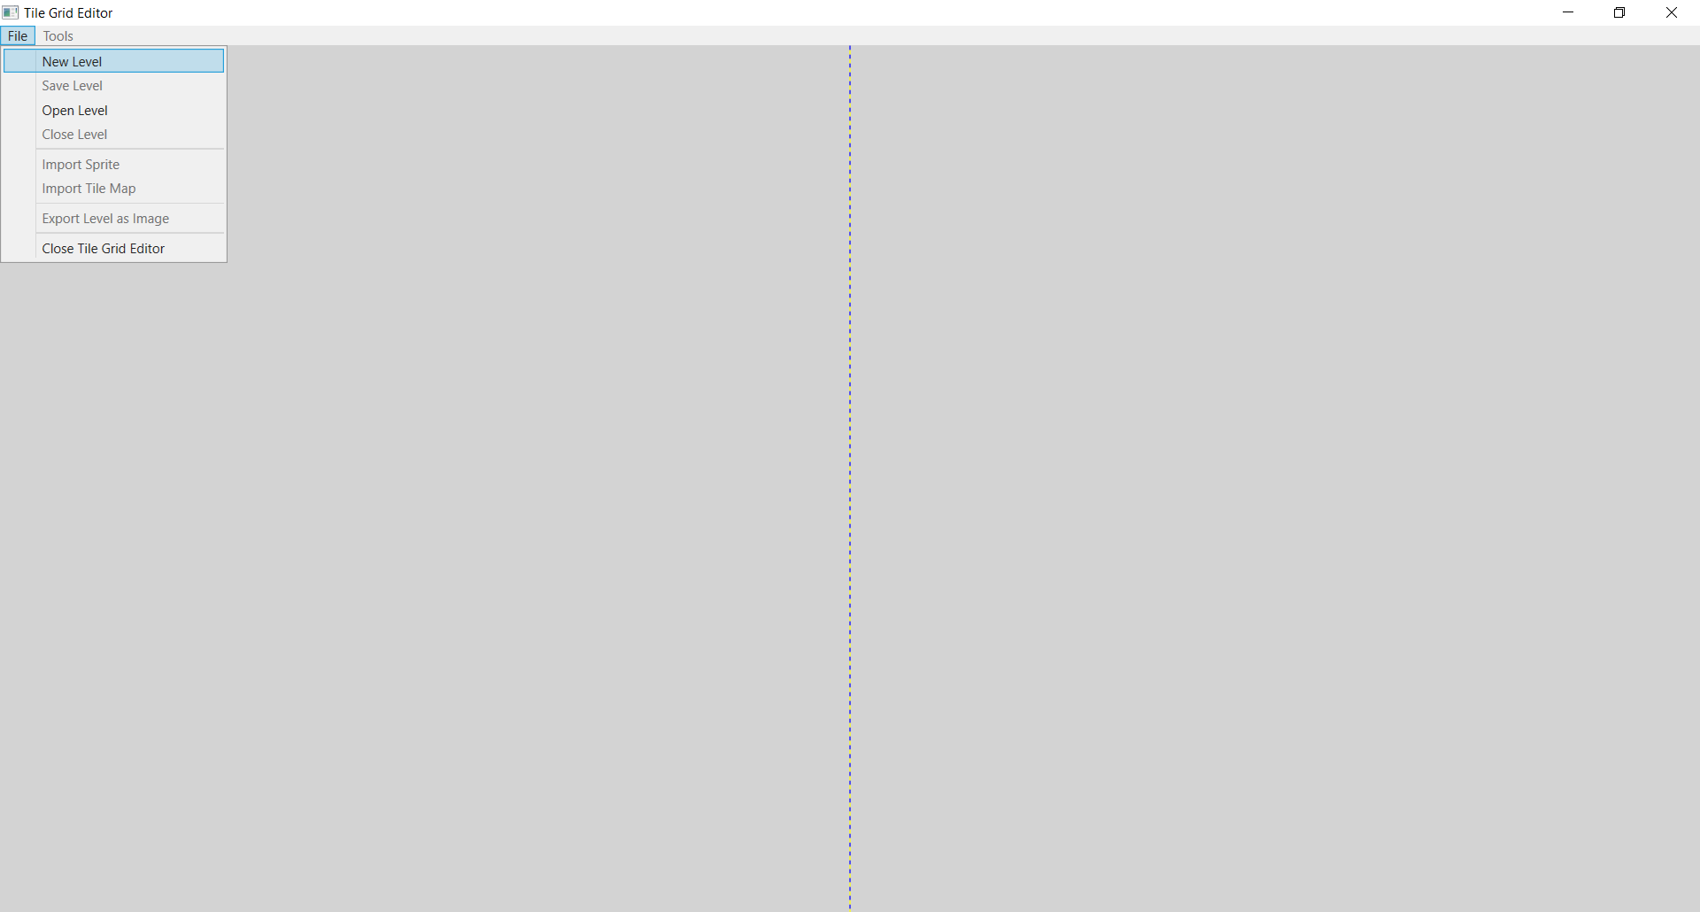

Open Level will open a Dialog Window, you need to navigate to your Level’s JSON File.

Close Level will close the currently Open Level.

Import Sprite will allow you to import Sprites which are 32 x 32 px. This sprite will be moved to your Level’s Sprite Folder.

Import Tile Map allows you to Import Tile Maps below 1024 x 1024 px. It will break the Tile Map up into Individual Sprites and add them to its own sprite tab. It will also add them all to you Level’s Sprite Folder.

Export Level as Image will Save your level to an PNG inside your Level’s Folder.

Close Tile Grid Editor will close the Program.

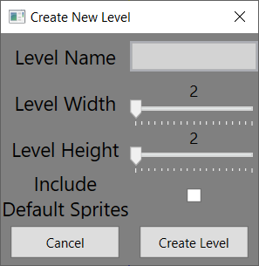

Level Name will be the Name of your Level and Folder.

Level Width will be how many Columns your Level will have.

Level Height will be how many Rows your Level will have.

Include Default Sprites will include 12 Single Sprites and 2 Tile Maps to your Level. (Disclaimer: Program will hang for a few moments, once it has started making the Level)

Starts to Create the Level.

Closes Window

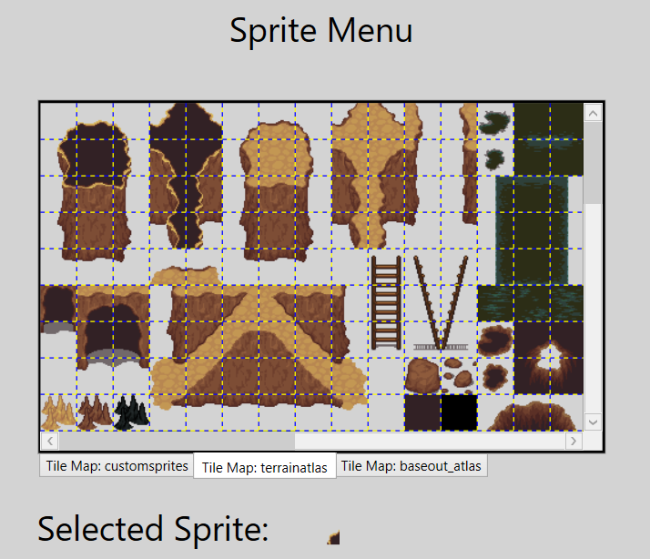

Sprite Grid where you choose which sprite to use on Level Grid.

Tabs for each Tile Map you have Imported. Custom Sprites are Single Tile Imports.

Show which Sprite you have Selected.

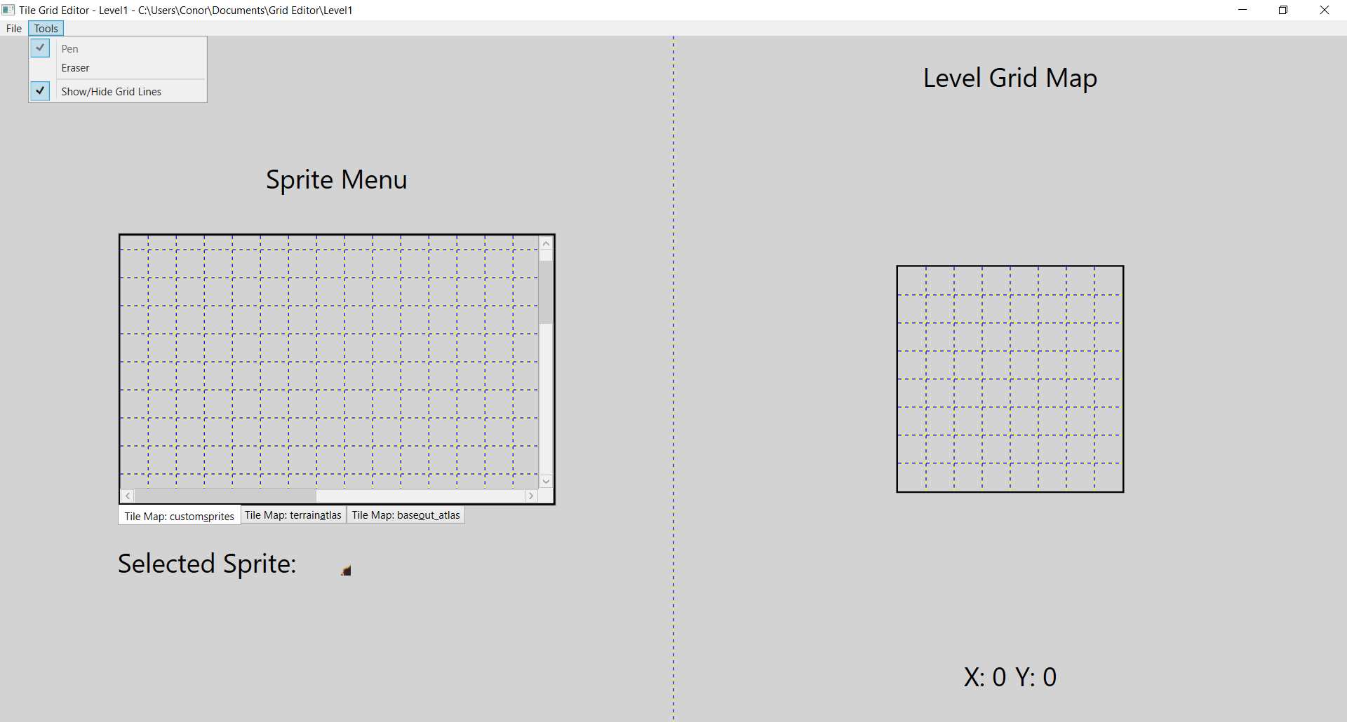

Level Name & Directory

Pen Tool draws onto Level Grid.

Eraser Tool removes tiles from Level Grid.

Option to Show or Hide Grid Lines on Level Grid.

Once you create a Level, it will save that Level and tell you the Directory in which the Level has been saved too.

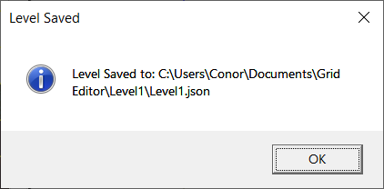

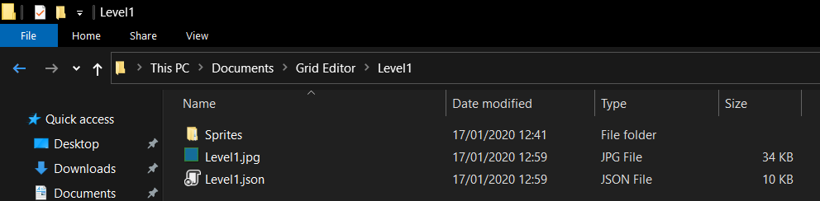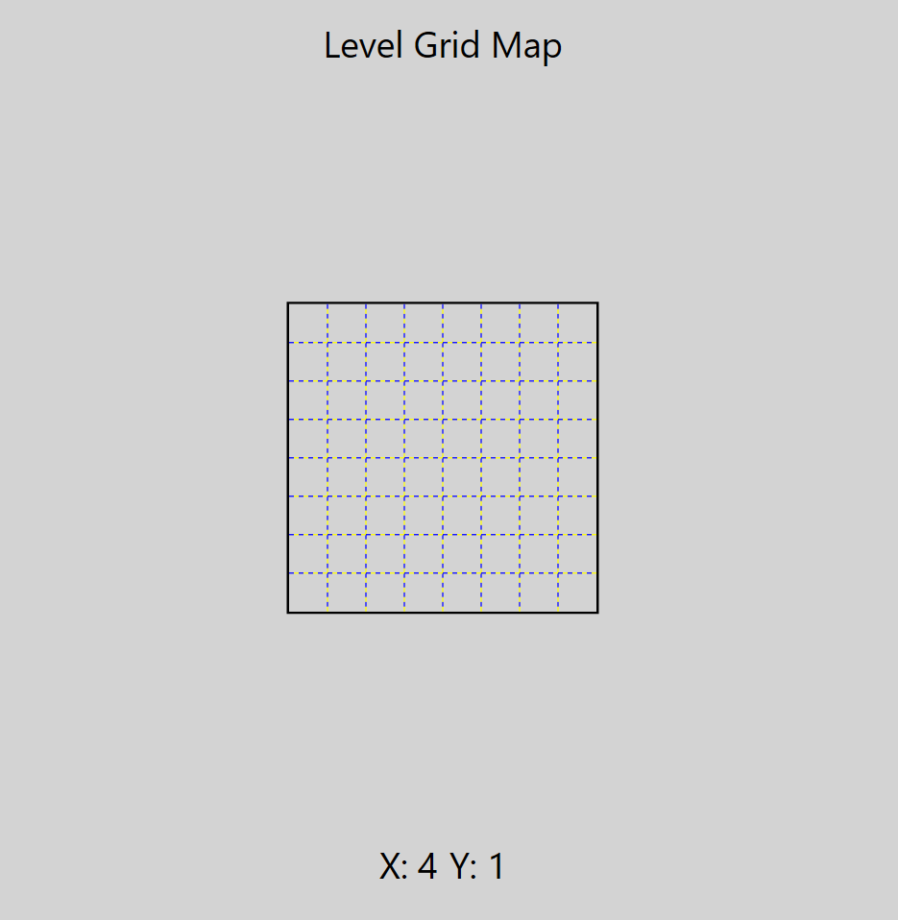

Optional: Exported Level Image

Level Save Data file

Level’s Sprites Directory

Level Directory Path

Current Coordinates of your Mouse Pointer on the Level Grid.

Level Grid where you draw the sprites onto.